|  |
| --- |
| **American International University- Bangladesh** |
| OOP1 Final Term Project Report SHOP Management System  Project Submitted By:  17-33434-1:: MD.ESTIAK AHMED  17-33431-1 :: ABDULLAH AL JAMI JOY  17-33392-1 :: MD. ARMAAN HOSSAIN CHAKLADER  17-33260-1 :: SAMIRA SOBHAN |

**Group No : B25**

**Course : OBJECT ORIENTED PROGRAMMING 1 (JAVA)**

**Section : B2**

**Date : 17-12-2018**

**Introduction:**

Amar Bazaar Management system is a demo project that can be modifiable with different shop management systems. This is a light project which has very easily designed interfaces to interact with users. The system maintains a quality relation with users by showing the products list, shows the accounts information, while ordering a product it deducts balance according to the price of that product. Admin panel members can add employee and give salary to them and also the admin can edit account information and seller can update the product information.

**User Category:**

There are 3 types of Users here. They are:

* Admin
* Seller
* Customer

**Feature List:**

In this project the “Admin” has the following features:

* An admin can change or update product information.
* An admin can add new product(s).
* An admin can delete product(s).
* An admin can change or update all type users account information.
* An admin can create new user account(s).
* An admin can delete all type user account.
* An admin can preorder for himself from him account.
* An admin can confirm order of other users.
* An admin has the access to see all type of users account information.

In this project the “Seller” has the following features:

* A seller can change or update product information.
* A seller can add new product(s).
* A seller can delete product(s).
* A seller can change or update only his account information.
* A seller can delete only his account.
* A seller can preorder for himself from him account.
* A seller can confirm order of other users.

In this project the “Customer” has the following features:

* A customer can create his own account.
* A customer can change or update him own account.
* A customer can delete him account.
* A customer can preorder product for himself.

**GUI Description:**

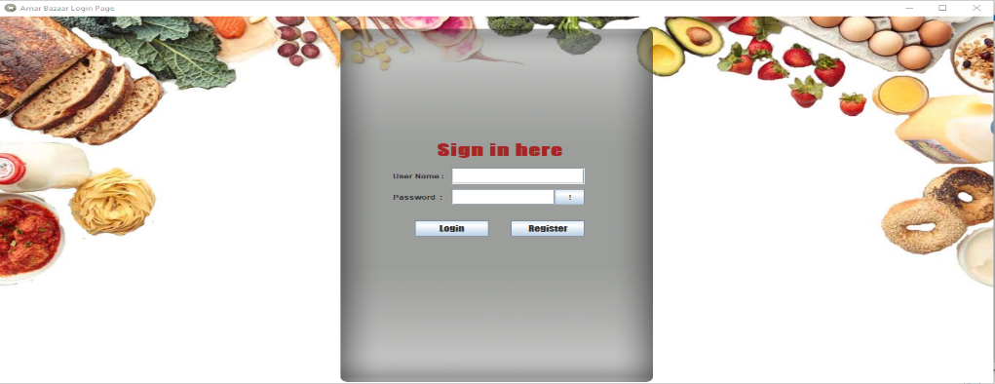

This is a login page GUI. Here user input there password and username to login to the system. If username or password do not match one cannot login to the system.

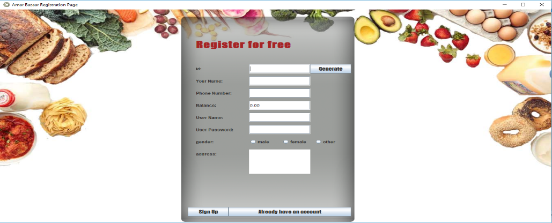

This is registration page GUI. A customer can sign up by giving proper information.

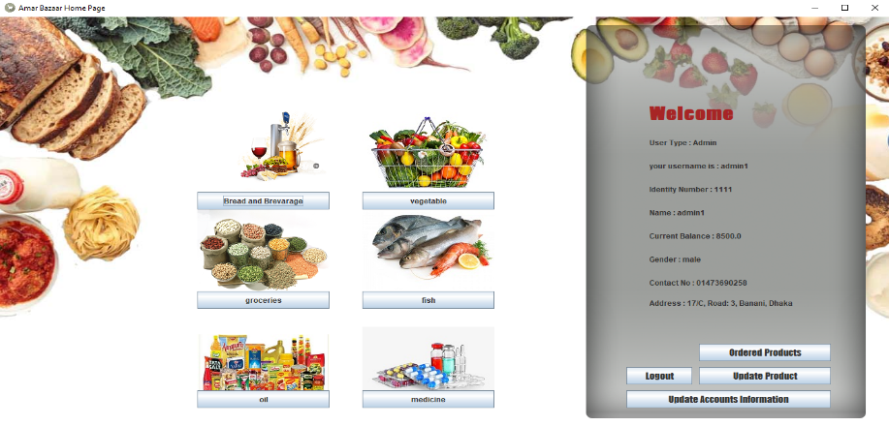

This is homepage GUI. Here a user can see his information. And also can go other option like update accounts or preorder products or check product list through given button.

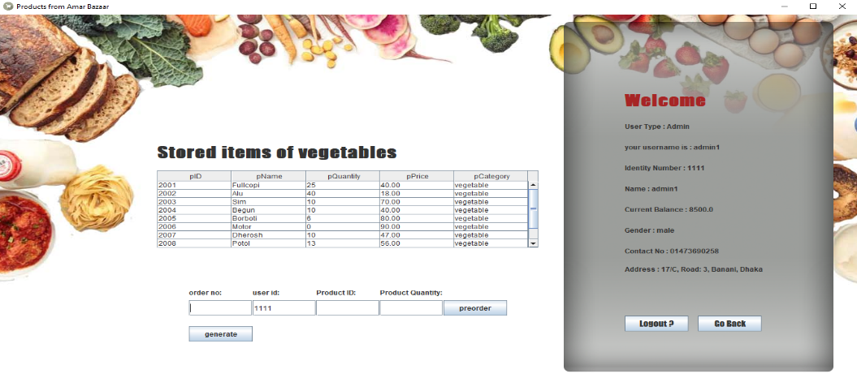

This is product page GUI. Where user can see product information and also can preorder products which he want.

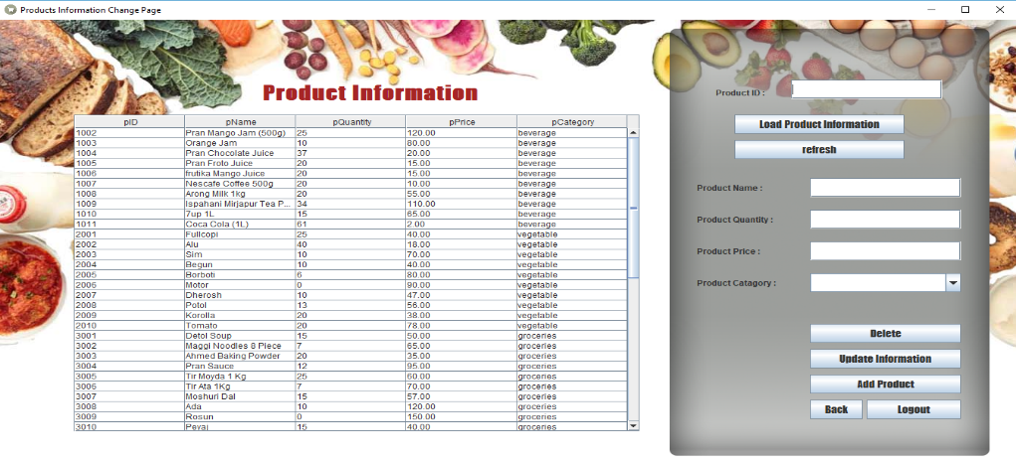

This is product update GUI. This page is only available for admin and sellers. Here admin or seller can change product information, delete product and add new product.

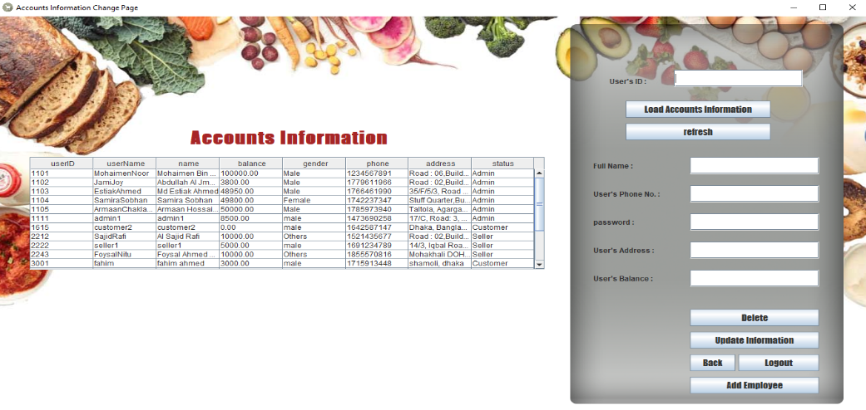

This is account update GUI. Here user can update or delete his account. Only for admin there are some special feature like add new employee. Customer and seller can only change or delete their own account. But admin can change or delete all type of users.

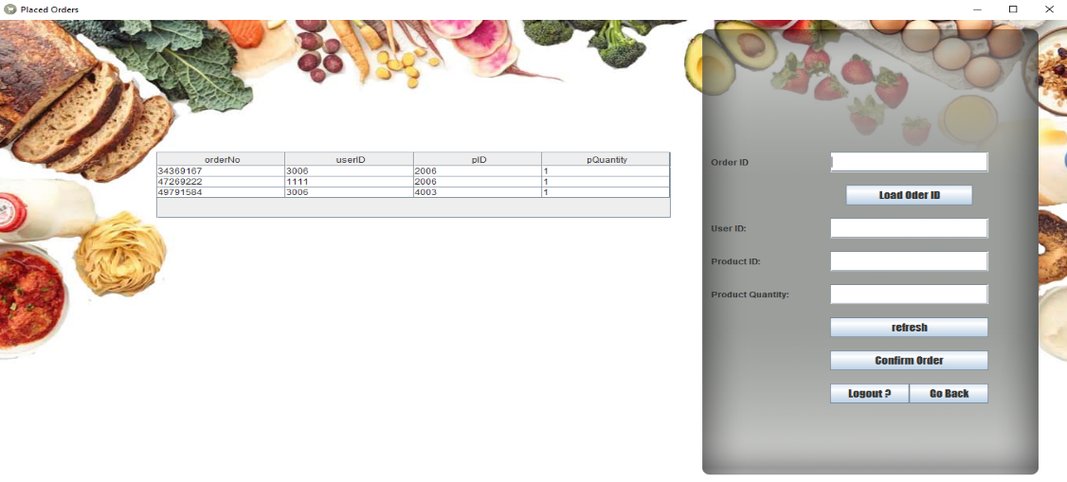

This is confirm order GUI. This GUI is only accessible for admin and seller. They can confirm orders from here.

**Database Table Description:**

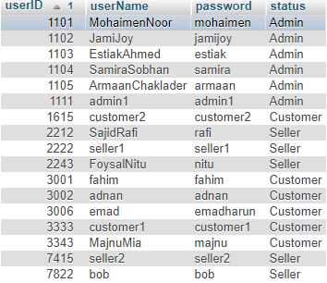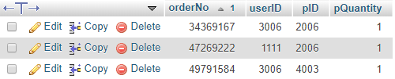

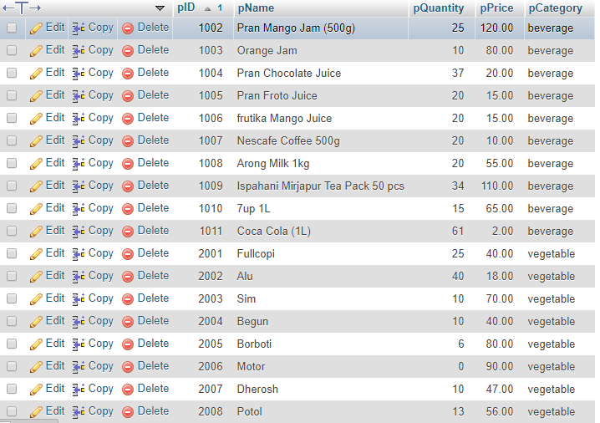

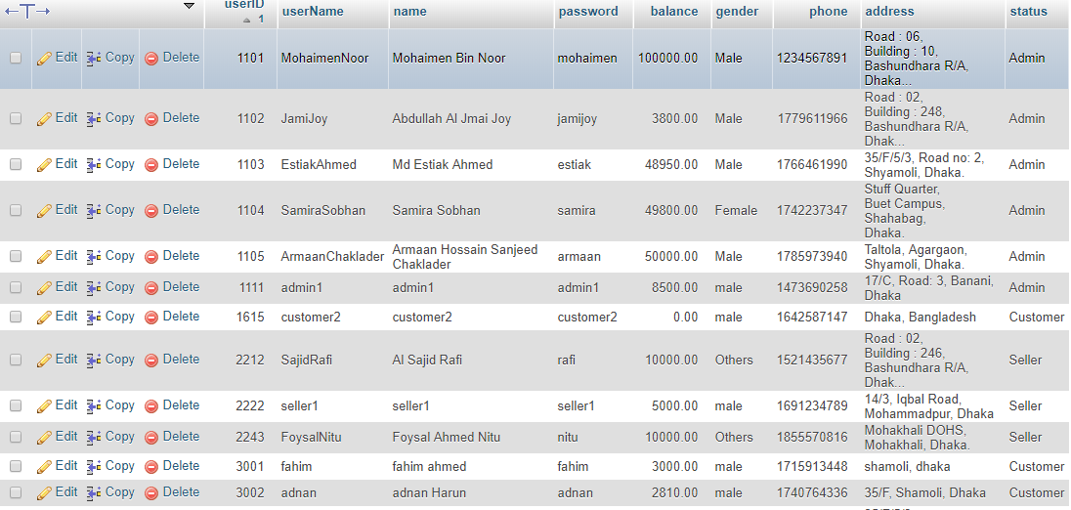

**Impact of this Project:**

Shop management systems are very much important for our country, briefly this type of management systems has direct interactions with the economic society. It is a very much essential for the business related people. As for its simple design implication and very fast interactions with users this project can help any shop management team’s work easier than before.

**Limitations and Possible Future Improvements:**

This is not an online base application. So users can’t use from different place through internet. The security system is not too much good. There is not two step verification system. Another main limitation is users can’t order multiple products at a time.

Afterwards we are planning for a PDF generated receipt page for orders of a Customer with orders details and also send them confirmation through email. The generated PDF file will be delivered through mail process. In newer updates we will add the feature of ordering multiple products.